**Resource Onboarding**

**ONLY For the New Mphasis resources – Below timelines will be followed**

*For other existing Mphasis resources (with laptop), Sprint allocation can be done sooner.

|  |  |  |
| --- | --- | --- |
| **#Working Day** | **Activity** | **SPOC** |
| Day 1 | Onboarding to Mphasis ( new joiners ) Induction to Mphasis | HR |
| Day 2 | Project onboarding | PMO - Arnold Theodore <Arnold.Theodore@mphasis.com> |
| Day 2 | Project Overview | PM |
| Day 2 | Raising the laptop request after the record is activated in the system | Resource himself (Requesting Laptop- Details included in the next pages) |
| Day 3 -Day 6 | Project KT by leads and Self Learning | Resource himself, Respective leads, Pos  (Project KT Links included in the next pages) |
| Day 3 | * Raise the access request – The typical SLA for getting the access is 3-5 working days * Add the resource to MS teams * Access to azure repos and dashboard | PM  Resource himself-  Ardonagh ID access issues: ( Write to )  Price Forbes IT Service Desk <[ArdonaghSpecialty@scc.com](mailto:ArdonaghSpecialty@scc.com)> |
| Day 3 -Day 6 | Co-ordinate for laptop shipping or collect physically from office | PMO - Arnold Theodore <Arnold.Theodore@mphasis.com> |
| Day 6 or 7 | Raise EASE+ request to install the requested software | Resource himself (Software Installation procedure – Details included in the next pages)  Ticketing issues (Write to )  IND-EASE-L1 <[IND-EASE-L1@mphasis.com](mailto:IND-EASE-L1@mphasis.com)> |
| Day 7 or 8 | Allocate to Sprint & send invitations for the daily sprint | SM |

**KT Links**

**Camunda / BPM overview – SPOC Ranjit Hardikar** [**Ranjit.Hardikar@mphasis.com**](mailto:Ranjit.Hardikar@mphasis.com)

[**https://mphasis.sharepoint.com/sites/PriceForbes/Shared%20Documents/General/Ardonagh%20Architecture/BPM%20Track**](https://mphasis.sharepoint.com/sites/PriceForbes/Shared%20Documents/General/Ardonagh%20Architecture/BPM%20Track)

**Integration & RPA overview - Vijayalaxmi Jugannavar <vijayalaxmi.j@mphasis.com>**

<https://mphasis.sharepoint.com/sites/PriceForbes/Shared%20Documents/General/Ardonagh%20Architecture/Integration%20Track>

**Platform components and other - Mohamedaslam A <Mohamedaslam.A@mphasis.com>**

<https://mphasis.sharepoint.com/sites/PriceForbes/Shared%20Documents/General/Ardonagh%20Architecture/Architecture%20Decisions>

**Process maps : mark cameron <mark.cameron@mphasis.com>**

<https://mphasis.sharepoint.com/sites/PriceForbes/Shared%20Documents/General/Induction%20and%20Training/Domain%20Training>

**Functional background on IBA and PP -**

<https://mphasis.sharepoint.com/sites/PriceForbes/Shared%20Documents/General/Induction%20and%20Training/Domain%20Training>

**Functional overview London market**

<https://mphasis-my.sharepoint.com/:v:/p/shripad_naik/ESwX1tPKr_FAuPP0JoWzJjoBRWJig2vuiNmKQvRjeAMgUg>

Additional Sessions are available in the following path in teams:

General 🡪 Induction and Training

**TRACKING ATTENDANCE - DAILY**

Open **App Access** link

<https://appaccess.mphasis.com/>

**Login with**

User Name – Employee ID

and

Password (as you received the initial password or current password)

If in case issue with user credentials, call Ease help desk Toll Free numbers

IND @ 1800 103 3273/1800 309 3273 | UK@ 44 8000322836

Alternatively write to

IND-EASE-L1 <[IND-EASE-L1@mphasis.com](mailto:IND-EASE-L1@mphasis.com)>

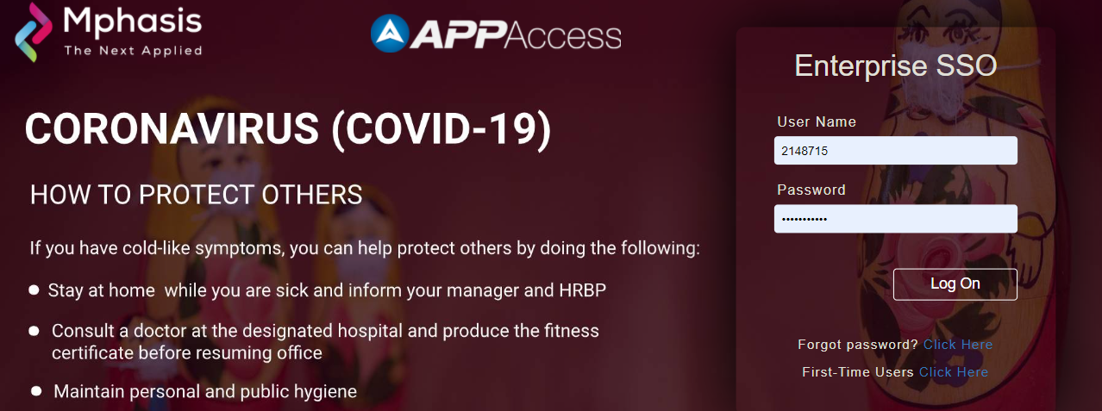

1) Select **Employee Outreach** menu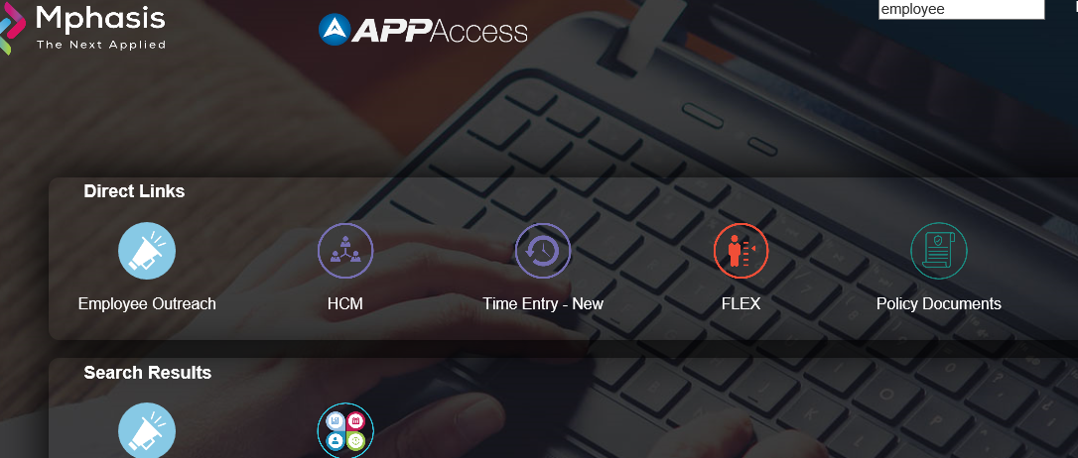

2) Select **Attendance Tracker**

**(**The Attendance Tracker app is specific to the current COVID-19 scenario and is crucial to login everyday as it helps us in tracking your health status**)**

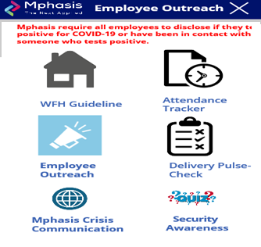

3) **Choose details** as appropriately

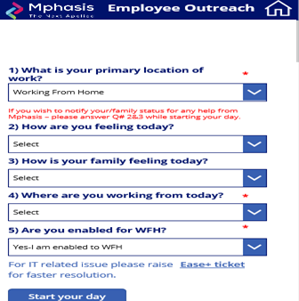

Click on **start your day** (First up in the morning, need to do this !!!)

Next screen shows your **START TIME**

4) **Add your activities**, **Hours** and **Save your Activity**

Mandated 9 hours (in Total) per day

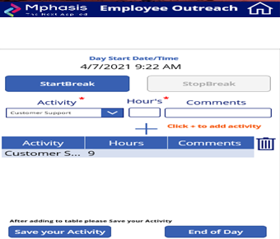

5) Click on **End of Day** once you are done for the day!

THAT’S ALL !!!

No other separate project time tracking is needed.

**APPLYING WFH**

Open AppAccess link

<https://appaccess.mphasis.com/>

1. **Click on Employee Services**

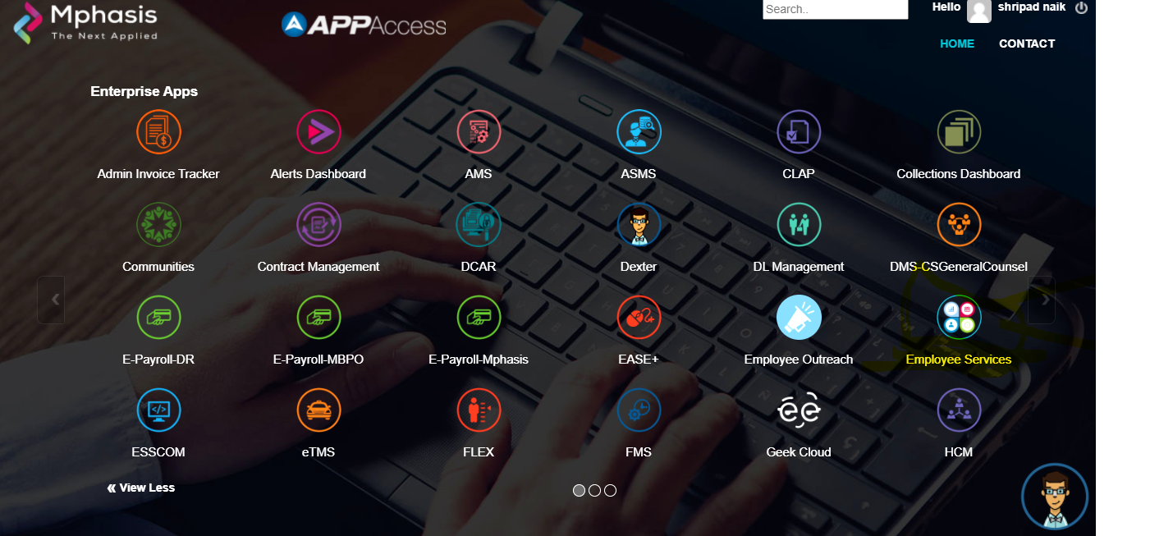

1. **Click on WSS ( Attendance)**

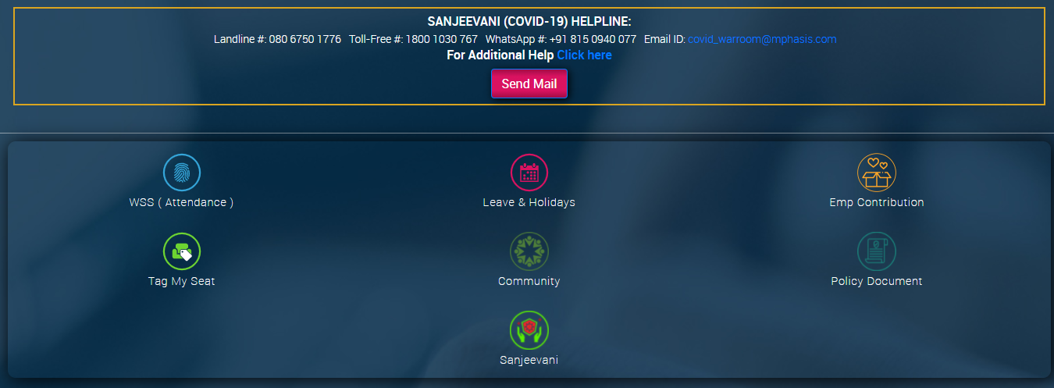

1. **Click on “Work From Home “**

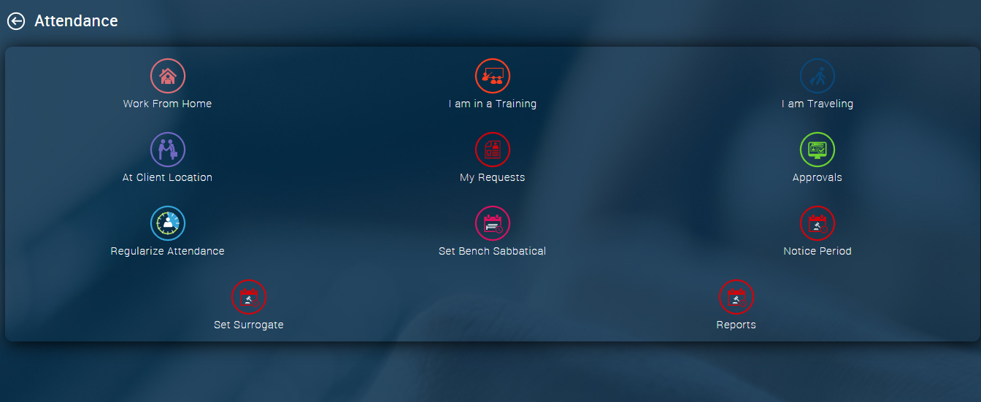

1. **Click on short term and apply for one month or required period.**

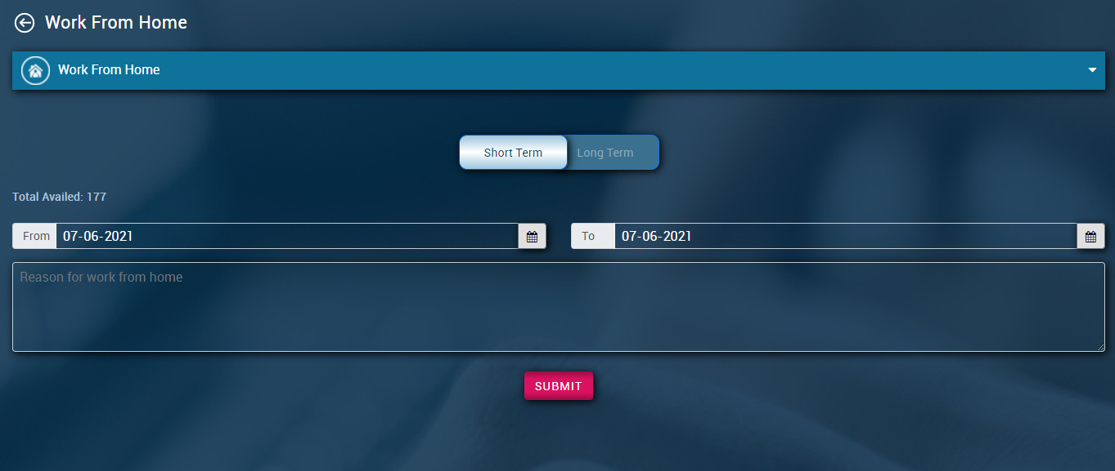

**Important: Leave Updates**

**Un-Planned Leave**

1. Apply for leave and get it approved even if WFH applied during the period
2. Inform your Leads and PM / DMs.

**Planned Leave –** Can be applied in advance after PM / DM’s approval

Go to **Employee Services 🡪 Leave & Holidays**

*Apply Leaves

**REQUEST A LAPTOP**

Open AppAccess link

<https://appaccess.mphasis.com/>

Enter (Ease+) in the search field once checked into the main menu

And click on **Ease+** Icon

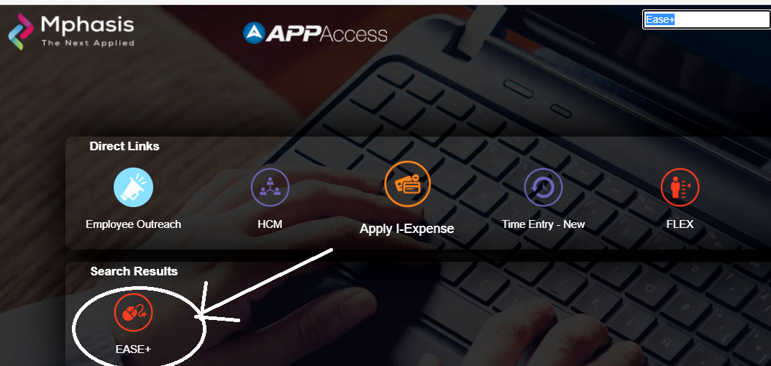

1. **Go into IT menu option as below**



1. **On the Left menu select “Hardware Services” and go to “New” option**

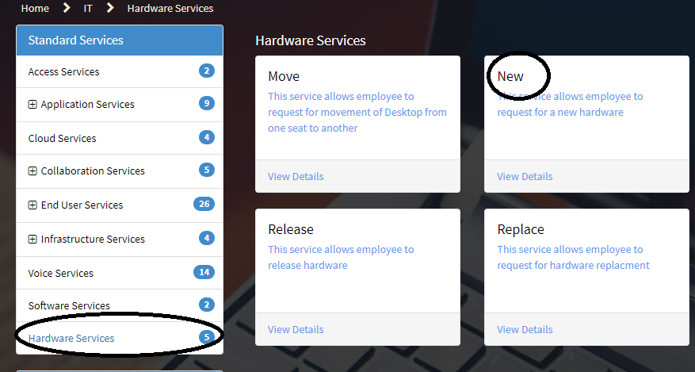

1. **Fill in the details as appropriate**

Cubicle Number (Say) L0000 or any Numeric value

Floor (Any) of your Base location as you know

Choose Project <**104430**> for Price Forbes

Request item <**Laptop**> and do Submit

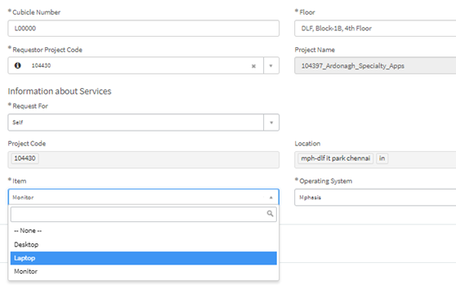

*Delivery Manager Approved request will be sent to Workplace Services (WPS) directly for provisioning a Laptop [Automated Workflow]

1. **Check status using below option**

**Home -** will guide to the home page land in the main content page, scroll down to see all the requests that you have placed

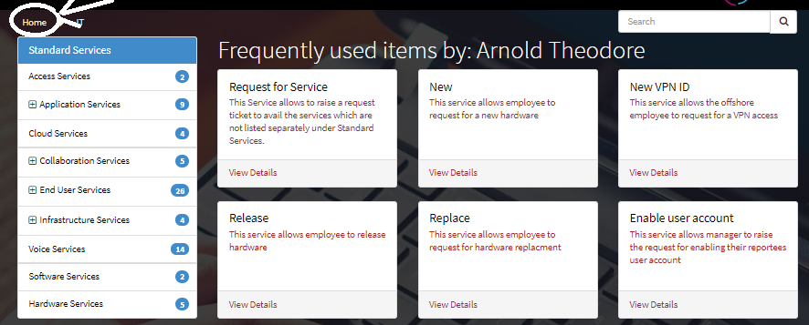

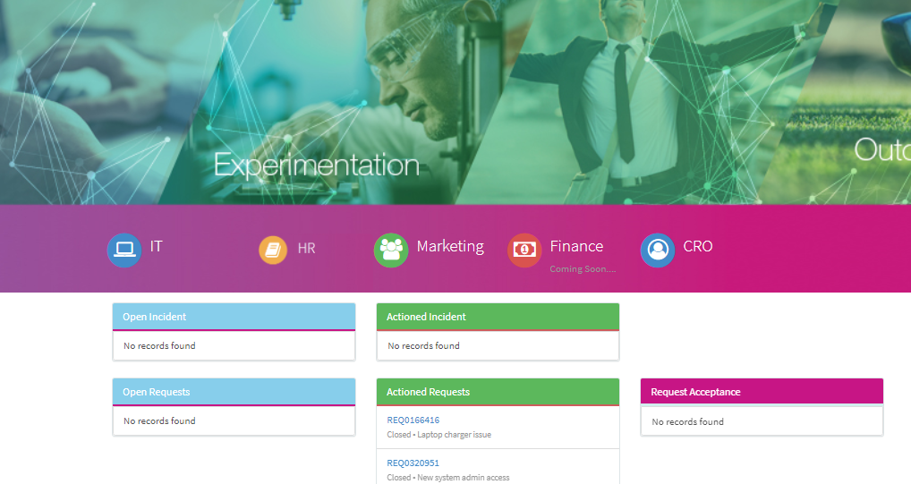

**Software Installation Procedure**

**Only software approved by Mphasis Software Asset Management(SAM) team may be installed and/or used in company-owned assets. All software installation on company-owned assets should have a valid Software Request raised on the requisition tool**

**Go to Appaccess EASE+ 🡪 IT🡪Software Services 🡪 New Software**

Note: For each software there will be different publisher, hence need to create individual request for each software. PLEASE DO NOT COMBINE multiple software’s in single request

**End of document.**